ORTHOPAEDIC INSTRUMENTS
Instruments For Veterinary Interlocking Nails
Bone Awl
Intended Use
The bone awl for veterinary interlocking nail systems is used to create the medullary canal entry portal in long bones before nail insertion. It perforates the cortex at the proximal nail entry point, initiating a channel aligned with the medullary canal axis for accurate interlocking nail placement in canine fracture fixation. | 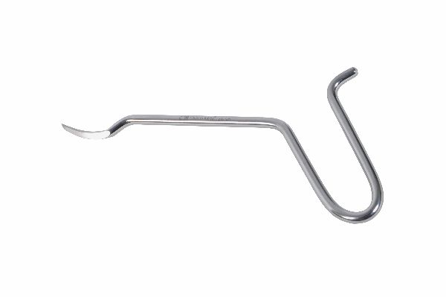
Function
The sharp, conical tip is driven into the cortex by mallet impaction, progressively opening the entry portal to a diameter that accommodates the interlocking nail without cortical splitting. The angled tip design follows the natural entry point geometry of canine tibial and femoral interlocking nail approaches.
Advantages
Precise Canal Entry Alignment: The awl establishes the nail's entry trajectory before insertion, ensuring the nail enters the canal in the correct axis to reach the fracture site without impinging against the endosteum and deflecting off course in long-span fixation.
Cold Cortical Perforation: Awl-based entry avoids the heat generated by power drilling at the portal site, protecting the cortical bone immediately around the entry from thermal necrosis that could weaken the nail's proximal locking screw purchase.
FAQ
Q: What entry sites are used for canine interlocking nail fixation?
A: The proximal tibia (medial to the tibial tuberosity) and the proximal femur (trochanteric fossa) are the standard entry sites for canine tibial and femoral interlocking nail fixation respectively.
Q: How is the awl oriented for correct nail trajectory?
A: The awl is aligned with the long axis of the medullary canal as visualised on biplanar radiographs; fluoroscopic guidance is recommended for precise trajectory confirmation before nail insertion.

ORTHOPAEDIC INSTRUMENTS
Instruments For Veterinary Interlocking Nails
Container for Vet Interlocking Set
Intended Use
The container for veterinary interlocking nail sets is a dedicated sterile organisation tray that holds all nail sizes, locking screws, and ancillary instruments of the interlocking nail system in a pre-arranged layout. It ensures all components are available and correctly identified during intraoperative fracture fixation procedures. | 
Function
Labelled recesses in a moulded tray body hold each nail, screw and instrument in a fixed, identifiable position. The tray is sterilised as a complete unit so the scrub nurse can confirm all components are present before surgery starts, and rapidly retrieve the correct size during implant selection.
Advantages
Complete Set Integrity: Tray organisation guarantees that all nails, locking screws, jig components and instruments are present and accounted for before surgery begins, preventing case interruption caused by missing components discovered mid-procedure.
Size Identification at a Glance: Embossed size markings beside each nail recess allow rapid nail and screw diameter selection without measuring, shortening operative time and reducing the risk of wrong-size implant errors under theatre lighting conditions.
FAQ
Q: How is the container processed between cases?
A: The container is disassembled, ultrasonically cleaned, re-organised with all components, and then steam sterilised as a complete set; tray audit against a component checklist ensures nothing is missing before sterilisation.
Q: Does the container also hold the targeting jig?
A: Yes — the proximal-distal targeting jig and all drill sleeves are accommodated in dedicated tray compartments, keeping the complete surgical system in one organised set for efficient theatre setup.

ORTHOPAEDIC INSTRUMENTS
Instruments For Veterinary Interlocking Nails
Depth Gauge – Long
Intended Use
The long depth gauge is used to measure the depth of locking screw holes drilled through an interlocking nail in the far cortex, ensuring correct locking screw length is selected for secure bicortical purchase. The extended shaft length reaches the nail locking holes in deep muscles of large breed dogs' femur and tibia. | 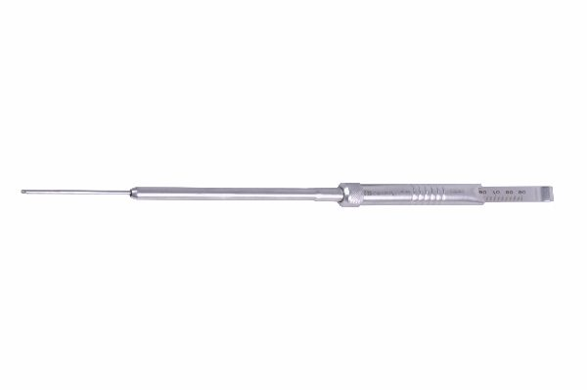
Function
The elongated shaft carries a hooked distal tip that passes through the drill sleeve and nail hole, catching the far cortex when advanced. The calibrated sliding indicator is pushed to the near cortex level, and the millimetre scale on the long shaft gives the measurement at a depth inaccessible to standard-length gauges.
Advantages
Reaches Deep Nail Holes: The extended shaft is purpose-designed for the depth of locking nail holes in large breed dogs where standard depth gauges cannot reach the far cortex through the thickness of femoral or tibial musculature without the gauge handle impeding access.
Accurate Bicortical Measurement: The hook reliably catches the far cortex through the nail hole even in curved or slightly irregular medullary canals, providing accurate measurements that prevent undersized locking screws — a primary cause of locking screw pull-out failure.
FAQ
Q: What length range does the long depth gauge cover?
A: Long gauges measure from 15 mm to 80 mm, covering locking screw lengths for small to giant breed dog tibial and femoral interlocking nail fixation.
Q: Why is screw length accuracy critical in interlocking nails?
A: A locking screw that is too short does not achieve bicortical purchase and provides inadequate rotational and axial stability; too long a screw protrudes excessively, causing soft tissue irritation and potential vessel injury.

ORTHOPAEDIC INSTRUMENTS
Instruments For Veterinary Interlocking Nails
Drill Bit S.S.
Intended Use
Stainless steel drill bits for veterinary interlocking nail systems are precision cutting tools used to drill locking screw holes through the nail holes in the far cortex after nail insertion. They are sized to match interlocking screw diameters, typically 3.5 mm, 4.0 mm or 4.5 mm in standard veterinary systems. | 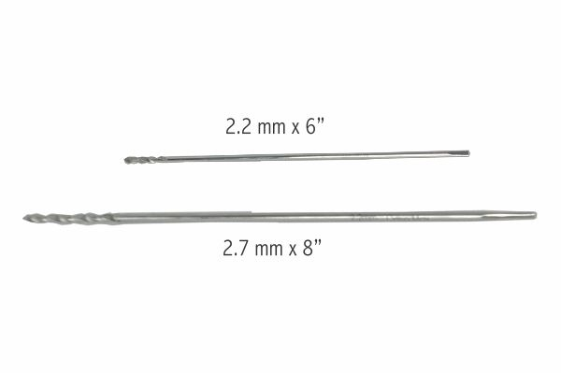
Function
The fluted tip cuts through the medial and lateral cortex and through the matching nail hole. The flute geometry evacuates bone debris away from the cutting tip, maintaining sharp cutting efficiency and preventing bone chip accumulation that would cause thermal build-up in the small-diameter locking hole.
Advantages
Nail-Hole Registration: The drill passes through the jig sleeve and nail hole simultaneously, ensuring the cortical hole is co-axial with the nail locking aperture — off-axis drilling misaligns the screw relative to the nail hole and prevents secure locking.
Corrosion Resistant All-SS Construction: Stainless steel construction prevents galvanic corrosion between the drill debris and titanium nail body, protecting the nail surface from accelerated corrosion at the locking hole margins during the bone healing period.
FAQ
Q: How many times should a drill bit be used before replacement?
A: Replace bits after 5–10 locking hole procedures; dull bits generate heat in the confined nail hole environment, and thermal necrosis of a locking hole reduces screw purchase strength.
Q: Are separate bits needed for titanium and stainless steel nails?
A: No — the same drill bits work for both nail materials; the bit cuts cortical bone, not the nail itself.

ORTHOPAEDIC INSTRUMENTS
Instruments For Veterinary Interlocking Nails
Drill Sleeve
Intended Use
The drill sleeve for interlocking nail systems threads into or registers against the targeting jig arm, guiding the drill bit precisely through skin and soft tissue to the cortex over each nail locking hole. It protects surrounding soft tissue from drill-bit laceration during locking screw hole preparation. | 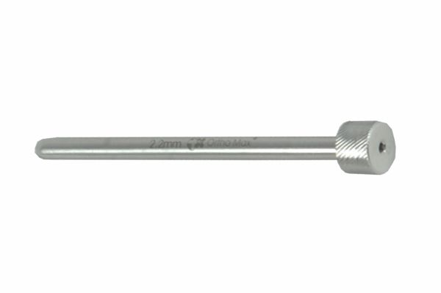
Function
The outer sleeve passes through the jig trocar and positions at the cortex over the nail hole. The inner bore aligns the drill bit co-axially with the jig arm and nail hole. The sleeve lip contacts the cortical surface, defining the drilling depth start point and preventing soft tissue wrap on the rotating drill bit.
Advantages
Soft Tissue Protection: The rigid sleeve isolates the rotating drill from muscle, fascia, nerves and vessels along the drill trajectory, preventing the drill-wrap injuries that cause significant post-operative morbidity in locking nail procedures.
Jig-to-Bone Alignment Maintenance: The sleeve maintains the drill on the jig-defined axis through each stroke, preventing the drill from deflecting off-axis as it passes through the soft tissue cone — deflection causes the hole to miss the nail hole and requires re-drilling.
FAQ
Q: Can the drill sleeve be omitted when locking freehand?
A: Freehand locking without a sleeve risks soft tissue entanglement and off-axis drilling that misses the nail hole; always use the sleeve even in freehand locking as a soft tissue protector.
Q: Does drill sleeve diameter affect locking accuracy?
A: The sleeve must match the jig trocar inner diameter exactly; a loose-fitting sleeve allows angular play that translates to millimetre-level hole offset at the cortex, potentially missing the nail aperture.

ORTHOPAEDIC INSTRUMENTS
Instruments For Veterinary Interlocking Nails
Extractor Set – Head
Intended Use
The interlocking nail extractor head is the proximal attachment component of the nail extraction system, connecting to the nail's proximal end to allow controlled reversal and withdrawal of the interlocking nail at implant removal surgery after fracture healing is confirmed. | 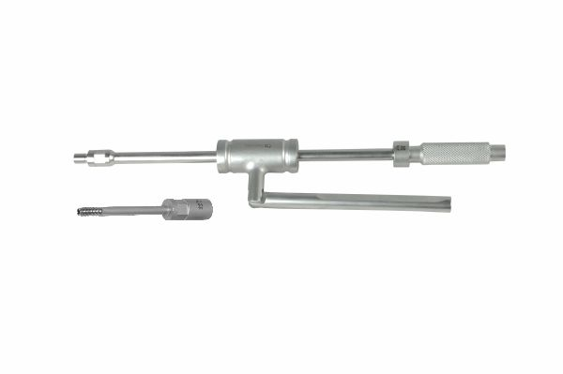
Function
The extractor head threads or hooks into the nail's proximal extraction interface. Once engaged, the head accepts the extractor rod, which is then used to apply axial reversal force. The head distributes the extraction load across the nail's proximal geometry, preventing nail deformation during removal.
Advantages
Secure Nail Interface: The threaded or bayonet engagement mechanism locks the extractor head to the nail's proximal end, preventing disengagement under the significant extraction forces needed to remove nails that have been in situ for several months.
Load Distribution: Head contact with the full proximal face of the nail distributes extraction force evenly, preventing the stress concentration that would deform the nail end if force were applied through a single-point contact.
FAQ
Q: When is nail extraction indicated?
A: Extraction is typically performed 3–6 months post-surgery once radiographic healing of the fracture is confirmed; early removal risks refracture through nail-dependent bone.
Q: What if the nail extraction interface is damaged?
A: If the proximal nail interface is stripped or deformed, the nail end must be exposed and the extractor pliers used to grip the nail body directly — a more technically demanding extraction approach.

ORTHOPAEDIC INSTRUMENTS
Instruments For Veterinary Interlocking Nails
Extractor Set – Rod
Intended Use
The interlocking nail extractor rod is the central shaft of the nail extraction system that transmits extraction force from the slotted hammer to the extractor head and into the nail during interlocking nail removal procedures in veterinary patients. | 
Function
The rod passes through the slotted extraction hammer and connects distally to the extractor head. Proximal hammer strikes travel along the rod body as a tensile impulse, transmitted through the head into the nail's proximal end, progressively withdrawing the nail from the medullary canal with each strike.
Advantages
Impulse Force Transmission: The rigid stainless steel rod efficiently transmits hammer impulse energy to the nail without energy loss from rod flex, ensuring each strike directly contributes to nail withdrawal — critical for removing nails with significant fibrous ingrowth.
Standard Length Coverage: Rod length is designed to accommodate the full range of femoral and tibial interlocking nail lengths used in large and giant breed dogs, providing consistent extraction mechanics regardless of the specific nail length chosen for the original fixation.
FAQ
Q: Can the extractor rod be used with nails from different manufacturers?
A: Extractor systems are generally manufacturer-specific; confirm that the rod-to-head connection and head-to-nail interface match the specific nail system used for original fixation.
Q: What length rod is needed for femoral nails?
A: Femoral interlocking nails are the longest commonly used; extraction rod length of at least 30 cm is typically needed to provide adequate handle clearance above the trochanteric entry site.

ORTHOPAEDIC INSTRUMENTS
Instruments For Veterinary Interlocking Nails
Extractor Set – Ram
Intended Use
The interlocking nail extractor ram is the slotted hammer component of the extraction assembly that generates the impactive reversal force required to withdraw a veterinary interlocking nail from the medullary canal after fracture healing is confirmed and locking screws have been removed. | 
Function
The heavy steel ram body contains a longitudinal slot that fits over the extractor rod. When slid forcefully along the rod shaft and decelerated by a proximal stop, the ram's kinetic energy is transferred as an impulsive extraction force through the rod into the nail, progressively loosening and withdrawing it from the canal.
Advantages
Sliding Impact Extraction: The ram mechanism generates significantly greater extraction force than manual traction alone, making nail retrieval reliable even when 3–6 months of periosteal and endosteal bone remodelling has partially encased the nail body in the canal.
Controlled Force Application: Strike strength is controlled by the surgeon's slide velocity; beginning with moderate strikes and gradually increasing provides progressive force escalation that loosens difficult nails without risking sudden instrument or implant fracture.
FAQ
Q: Must locking screws be removed before using the extractor ram?
A: Yes — all proximal and distal locking screws must be removed before ram extraction; attempting to extract the nail with screws in place will fracture the screws within the nail hole, creating a complex retrieval situation.
Q: What if the nail does not move after 20 ram strikes?
A: Pause and rotate the nail through the extractor head to break any fibrous adhesion, then resume ram extraction; if still immovable, obtain imaging to confirm full screw removal and canal anatomy before proceeding.

ORTHOPAEDIC INSTRUMENTS
Instruments For Veterinary Interlocking Nails
Hexagonal Screwdriver
Intended Use
The hexagonal screwdriver in the veterinary interlocking nail set is used to insert and remove hex-socket locking screws that pass through the nail holes to prevent rotation and axial collapse at the fracture site. Secure locking screw insertion is critical to achieving the rotational and axial stability required for fracture healing with interlocking nail fixation. | 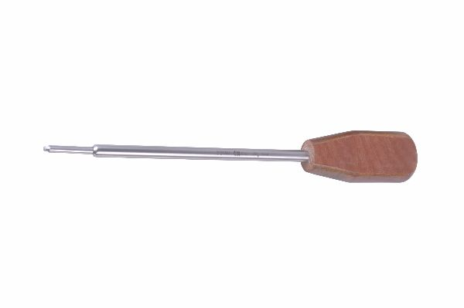
Function
A precision-machined hex tip engages the locking screw's socket head fully. The surgeon applies controlled rotational torque through the T-bar or palm handle, driving the screw through both cortices and the nail hole until the head seats flush against the lateral cortex without over-torquing the screw-bone interface.
Advantages
Full Socket Engagement: The hex tip seats to full depth in the locking screw socket, transmitting torque across the full hex perimeter and preventing the cam-out that would strip the screw head — a serious complication requiring specialised removal instruments.
Tactile Torque Control: Direct manual torque delivery allows the surgeon to feel the change in resistance at full screw seating, preventing the over-torquing that strips cortical threads in the locking hole and reduces screw purchase in osteopenic bone.
FAQ
Q: What hex tip size is used for interlocking screws?
A: Most veterinary interlocking screw systems use 2.5 mm hex socket screws of 3.5–4.5 mm diameter; confirm the hex size against the specific nail system specifications.
Q: Should locking screws be tightened to a specific torque?
A: Manual seating to tactile resistance is standard; torque-limiting drivers set to 1.5–2.0 Nm may be used in osteopenic patients to prevent thread stripping.

ORTHOPAEDIC INSTRUMENTS
Instruments For Veterinary Interlocking Nails
Impactor Head
Intended Use
The impactor head is the distal attachment of the nail insertion instrument, connecting to the proximal end of the interlocking nail and transmitting mallet impact force during nail driving into the medullary canal. It protects the nail's proximal tip from deformation during the impaction process. | 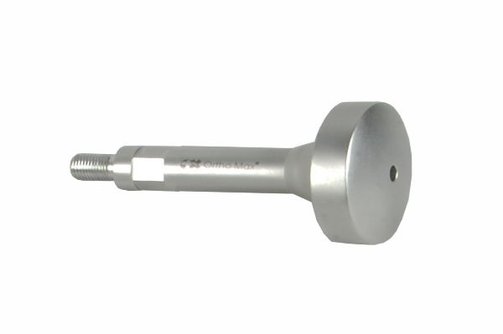
Function
The impactor head threads or snap-fits onto the nail's proximal end. The flat proximal face accepts mallet strikes directly. The interface geometry distributes impact force across the full nail cross-section, advancing the nail without deforming the proximal nail hole geometry that is needed later to accept the locking screws.
Advantages
Nail Tip Protection: The impactor head absorbs and distributes mallet impact across the nail's proximal face, preventing the mushrooming and deformation of the proximal nail end that would occur with direct mallet-to-nail contact and compromise locking screw insertion.
Reliable Impact Transfer: A solid metal-to-metal interface between impactor head and nail ensures full energy transfer from each mallet strike, without the energy absorption that rubber or polymer impaction buffers introduce, maintaining crisp tactile feedback during nail advancement.
FAQ
Q: Can the impactor head also function as the extractor interface?
A: Some systems use a single head that serves both impaction and extraction — confirm with the specific nail system manual before attempting extraction through an impaction-only interface as this may damage the nail head.
Q: How is the impactor head attached to the nail?
A: Most veterinary interlocking nail systems use a threaded or bayonet-lock interface that allows rapid attachment and removal while maintaining secure engagement under repeated mallet strikes.

ORTHOPAEDIC INSTRUMENTS
Instruments For Veterinary Interlocking Nails
Intramedullary Reamer Solid
Intended Use
The solid intramedullary reamer is used to enlarge the medullary canal prior to interlocking nail insertion in veterinary orthopaedic surgery. Canal reaming to a diameter 1–1.5 mm larger than the selected nail allows nail insertion without excessive force while increasing the nail-to-canal contact area for improved fixation stability. | 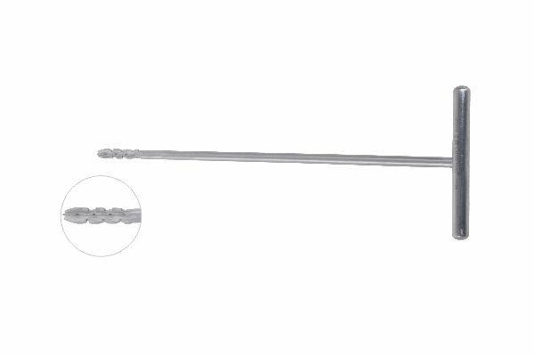
Function
The solid reamer body carries helical flutes with hardened cutting edges. Rotated by a T-handle, the flutes progressively enlarge the canal from the entry portal to the isthmus. Bone reamings are expelled proximally, clearing the canal. Sequential reamers in increasing diameters allow stepwise enlargement to the target size.
Advantages
Facilitates Nail Insertion: Reaming the canal 1–1.5 mm larger than the nail eliminates the cortical friction that would otherwise require excessive impaction force, reducing the risk of iatrogenic cortical splitting during nail insertion in dense diaphyseal bone.
Biologic Reaming Effect: Canal reaming liberates autologous endosteal bone graft that is deposited at the fracture site, providing osteogenic cells and growth factors that supplement fracture healing biology — a significant benefit in comminuted or delayed fracture presentations.
FAQ
Q: Is reaming always required before interlocking nail insertion?
A: Unreamed nailing is preferred in some fracture types to minimise endosteal disruption; however, in dense canine diaphyseal cortex reaming is usually required for nails >8 mm diameter to allow insertion without excessive impaction force.
Q: How much should the canal be reamed relative to nail diameter?
A: Ream to 1.0–1.5 mm larger than the nail outer diameter; over-reaming weakens the cortex around the canal, reducing the friction fit that contributes to nail stability.

ORTHOPAEDIC INSTRUMENTS
Instruments For Veterinary Interlocking Nails
Nail Holding Bolt
Intended Use
The nail holding bolt is used to secure the targeting jig to the proximal end of the interlocking nail before insertion. The bolt maintains a rigid connection between the nail and jig throughout the insertion process, ensuring the jig arm holes remain accurately aligned with the nail locking apertures for freehand or guided distal locking. | 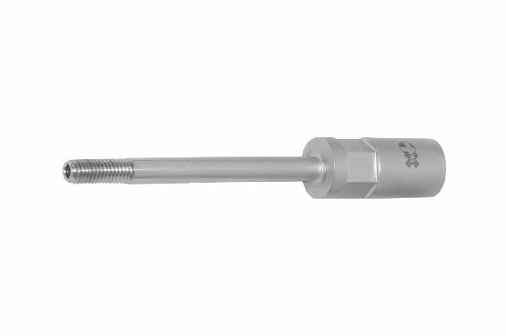
Function
The bolt threads into the nail's proximal interface, drawing the jig mounting face tight against the nail end. The rigid interface transmits the jig's orientation to the nail, so that jig arm positions accurately predict locking hole locations within the bone — essential for accurate distal locking screw placement through small cortical holes.
Advantages
Rigid Jig-to-Nail Interface: A firm mechanical connection eliminates angular play between the jig and nail; even 1–2° of play translates to several millimetres of locking hole position error in long nails, potentially causing the drill to miss the nail aperture.
Maintains Alignment Through Insertion: As the nail is driven into the canal, the bolt maintains jig co-registration with the nail hole positions, allowing continuous intraoperative verification that the jig arms remain correctly oriented relative to the nail.
FAQ
Q: How tightly should the bolt be tightened?
A: Finger-tight plus a quarter turn is sufficient; over-tightening can strip the nail's proximal thread interface, while under-tightening allows jig wobble that misdirects locking drills.
Q: Is the bolt removed before locking screw insertion?
A: Yes — the bolt is removed after nail insertion to allow locking screw insertion through the jig arm trocar positions; it may be reinstalled if the jig needs repositioning.

ORTHOPAEDIC INSTRUMENTS
Instruments For Veterinary Interlocking Nails
Protection Sleeve
Intended Use
The protection sleeve in the veterinary interlocking nail system is a soft tissue protective tube placed through the stab incision over each locking screw hole site. It guards muscles, nerves and vessels from the rotating drill during locking hole preparation and from the advancing screw during locking insertion. | 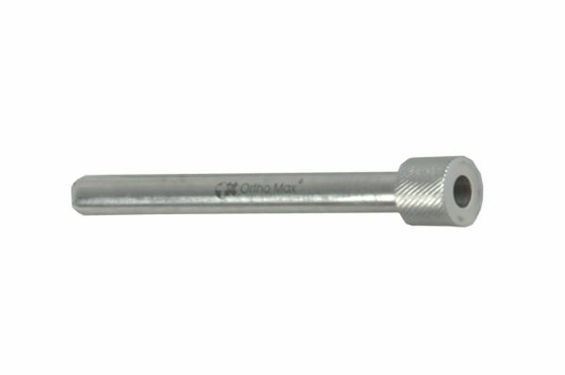
Function
The outer diameter sleeve passes through the skin stab incision and abuts the bone cortex over the locking hole site. The drill bit, depth gauge and locking screw then pass through the sleeve lumen sequentially, with the sleeve wall isolating them from surrounding soft tissue at every stage of the locking procedure.
Advantages
Neurovascular Protection: The sleeve prevents the drill from contacting nerves and vessels adjacent to the locking holes — particularly important at the distal femoral locking sites where the peroneal nerve and popliteal artery are within millimetres of the lateral cortex.
Soft Tissue Track Preservation: Maintaining the same sleeve position through drilling, depth gauging and screw insertion preserves the soft tissue stab incision track, minimising the tissue trauma that accumulates when instruments are inserted and removed multiple times without guidance.
FAQ
Q: Can one sleeve be used for all locking holes?
A: Each sleeve should be repositioned to the correct cortical site for each hole — do not attempt to angle the sleeve from one incision to reach an adjacent locking hole, as this creates off-axis drilling.
Q: Is the protection sleeve part of the jig assembly?
A: The sleeve fits through the jig arm trocar when guided locking is used, or is placed independently through a separate stab incision when freehand locking without a jig is performed.

ORTHOPAEDIC INSTRUMENTS
Instruments For Veterinary Interlocking Nails
Proximal–Distal Jig for Vet Nails
Intended Use
The proximal-distal targeting jig for veterinary interlocking nails is the primary aiming device that allows accurate placement of both proximal and distal locking screws through the nail holes without fluoroscopic confirmation of each individual screw. It mounts to the nail and mechanically aligns drill guides with the nail's locking apertures. | 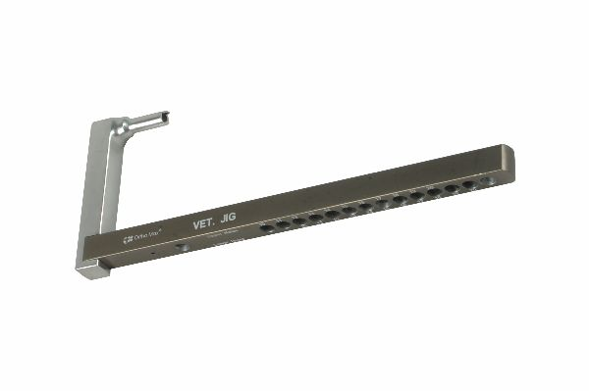
Function
The jig frame connects rigidly to the nail through the nail holding bolt. Proximal and distal arm positions carry trocar holes precisely co-registered with the nail's locking hole positions. When the nail is seated in the canal, the jig arm positions define the skin entry points and drilling trajectories for each locking screw site.
Advantages
Reduces Radiation Exposure: Jig-guided locking reduces the number of fluoroscopic confirmations needed during screw placement, lowering radiation exposure to the patient, surgeon and theatre team — a significant benefit in training environments where multiple locking attempts are common.
Accurate Distal Locking: Distal locking is the most technically demanding step of interlocking nail fixation; the jig's distal arm pre-registers the drill path with the nail hole, achieving accurate first-pass locking that avoids the multiple failed drill attempts associated with freehand distal locking technique.
FAQ
Q: Why does the jig sometimes fail to align correctly for distal locking?
A: Nail bending within the canal shifts the distal end relative to the jig's original position; slight fluoroscopic correction or adjustment is needed in long nails when the canal curves the nail during insertion.
Q: Is the jig sterilised with the nail or separately?
A: The jig is sterilised separately as a reusable instrument; the nail is typically provided sterile in its own packaging and the jig is attached under sterile conditions after nail preparation.

ORTHOPAEDIC INSTRUMENTS
Instruments For Veterinary Interlocking Nails
Tissue Protector
Intended Use
The tissue protector is a broad-bore soft tissue guiding instrument used during initial nail entry portal creation and early nail insertion in the veterinary interlocking nail system. It dilates the soft tissue path from the skin incision to the cortex, protecting muscles and vessels from the awl and nail during the entry phase. | 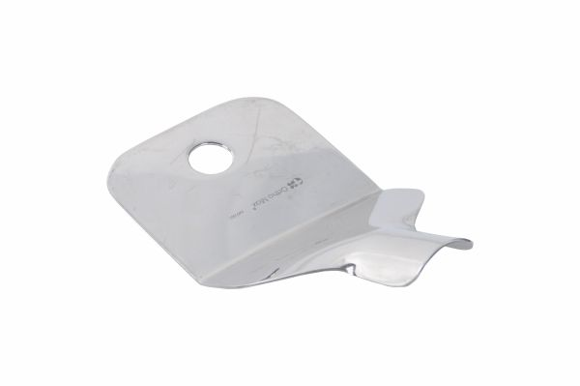
Function
A tapered outer sleeve is introduced through the stab incision and advanced to the cortical surface under tactile guidance. The awl or nail then passes through the sleeve lumen, fully isolated from surrounding tissue. The wide bore accommodates the nail diameter, preventing soft tissue wrap during initial nail insertion.
Advantages
Entry Phase Soft Tissue Safety: Protecting soft tissue during the forceful entry portal creation phase prevents the avulsed muscle fibres and vessel injuries that can occur when the awl or nail contacts rotating or squeezing tissue during insertion.
Maintains Incision Path: The sleeve keeps the entry incision dilated and aligned with the nail axis throughout the insertion sequence, preventing the incision from closing around the nail during insertion and causing skin drag that misdirects the proximal nail entry angle.
FAQ
Q: Is the tissue protector different from the protection sleeve used for locking?
A: Yes — the tissue protector is larger and designed for the entry portal site; the protection sleeve is smaller, placed over individual locking hole sites and used during the locking screw insertion phase.
Q: Can the tissue protector be used as a drill guide?
A: It is not designed as a precision drill guide; use the dedicated drill sleeve through the jig arm for accurate locking hole drilling rather than the tissue protector.

ORTHOPAEDIC INSTRUMENTS
Instruments For Veterinary Interlocking Nails
Tommy Bar
Intended Use
The Tommy bar is a cross-handle instrument used to rotate the T-handle or nail body manually when the nail requires rotational adjustment during insertion or when proximal locking screws need to be aligned with the jig arm positions. It provides torque without the wrist fatigue associated with sustained T-handle rotation. | 
Function
A transverse bar passes through the handle of the T-handle assembly or directly through the nail holder. The surgeon grips both ends of the Tommy bar and applies rotational force, turning the nail within the canal without the wrist-twisting motion required when using the T-handle alone for nail rotation.
Advantages
Ergonomic Rotational Control: The two-handed grip on the Tommy bar provides smooth, controlled nail rotation with significantly less wrist fatigue than single-hand T-handle rotation, important during the sustained nail positioning needed for accurate jig co-registration.
Precise Rotation Adjustment: Fine rotational corrections of 5–10° are easier to achieve with the Tommy bar's bilateral grip than with a single T-handle, allowing accurate alignment of the jig arm with the nail hole positions for reliable locking.
FAQ
Q: When is the Tommy bar used instead of the T-handle alone?
A: The Tommy bar is used when the nail requires more than a quarter turn of rotation, when access to the single T-handle is restricted, or when fine precise rotation control is needed for jig alignment.
Q: Does the Tommy bar engage the nail directly?
A: It connects to the T-handle assembly that grips the nail; the bar provides additional handle leverage rather than direct nail engagement.

ORTHOPAEDIC INSTRUMENTS
Instruments For Veterinary Interlocking Nails
Trocar Awl with T Handle
Intended Use
The trocar awl with T handle is used to create the cortical entry portal for veterinary interlocking nail insertion, providing the manual grip and directional control needed to penetrate cortical bone precisely at the designated entry point. The T-handle configuration allows bimanual force application for effective cortical penetration. | 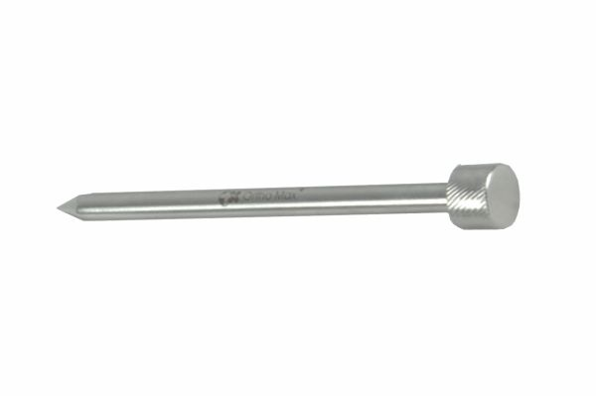
Function
The T-bar handle is gripped with both hands to apply axial pressure and rotational force simultaneously. The trocar tip at the distal end penetrates cortex using a combined push-and-rotate motion, progressively boring through the cortical shell to create a smooth, centred entry portal aligned with the medullary canal.
Advantages
Bimanual Control: The T-handle configuration allows the surgeon to simultaneously apply axial pressure with one hand and rotational force with the other, creating a push-and-rotate penetration technique that is more controlled and accurate than single-hand awl use.
Secure Entry Portal: The trocar tip geometry creates a clean, smooth-walled entry portal that guides the nail into the canal without leaving rough edges that could deflect the nail tip off its intended trajectory during insertion.
FAQ
Q: Is the T-handle trocar awl reusable?
A: Yes — it is sterilised as part of the interlocking nail instrument set; inspect the trocar tip before each case for blunting or bending and replace when tip integrity is compromised.
Q: How deep is the entry portal created with the trocar awl?
A: The trocar is advanced until it fully penetrates the near cortex and enters the medullary canal by 1–2 cm; this establishes the entry direction and initial canal path for nail insertion.

ORTHOPAEDIC INSTRUMENTS
Instruments For Veterinary Interlocking Nails
Wrenches – Spanner Simple
Intended Use
The simple spanner wrench set is used in veterinary interlocking nail procedures to tighten the nail holding bolt connecting the targeting jig to the nail, and to install or remove any threaded components of the interlocking nail system. The spanners provide the controlled torque needed to achieve secure connections without over-tightening. | 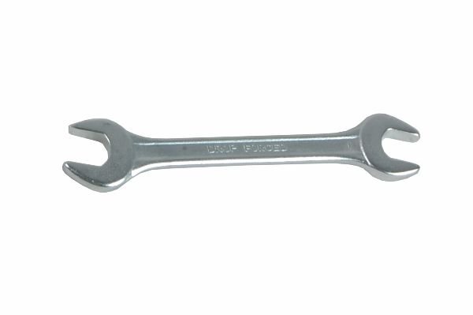
Function
Open-ended or box spanners in specific sizes engage the hex or square nut profiles of interlocking nail system components. The handle length provides appropriate mechanical advantage for the torque levels required, while the precision-machined jaw engagement prevents rounding of small implant fastener profiles under tightening force.
Advantages
Prevents Interface Fastener Stripping: Spanners apply torque through full nut face engagement, distributing force evenly around the fastener perimeter — unlike adjustable wrenches that can slip and round the nut corners of small implant hardware, making disassembly difficult.
System-Specific Sizing: Spanners matched to the specific fastener sizes of the interlocking nail set eliminate the risk of using wrong-size generic tools that are marginally undersized and strip the fastener profile, particularly important for the small metric fasteners common in veterinary implant systems.
FAQ
Q: What sizes are included in a standard veterinary interlocking nail spanner set?
A: Most sets include 8 mm, 10 mm and 13 mm spanners covering the nail holding bolt, jig fasteners, and ancillary components across common veterinary interlocking nail systems.
Q: Should the nail holding bolt be torqued with a spanner or by hand?
A: Finger-tight plus a quarter-turn with the spanner is adequate — the bolt must not be over-torqued as this can damage the nail's proximal thread interface, making later bolt removal difficult.

